**KIBUUKA MIXED PRIMARY SCHOOL - NANSANA**

**P.2 ENTRY INTERVIEW, 2023**

**Pupil’s Name___________________________________________**

**ENGLISH**

1. **Name these pictures.**

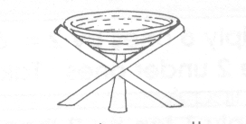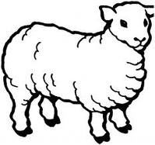

­­­­­­­­______________ ____________ __________

1. **Use the word in brackets correctly.**
2. The boy is ________________ his shirt. (wash)
3. They are ________________ on a bench. (sit)
4. Mummy is ____________________ a cake. (bake)
5. **Answer correctly.**

a) Where is the doll?

 __________________________________________________

b) Is the pot on the chair?

F:\ \PRETTIE FOLDER\PRETTIE AND PRECIOUS\BACK-UP\amper aliya\WORK CLEAN\NEW ORGANISED WORK\ACHIEVERS' WORK ALL\ALL diagrampics\diagram 2\PICS 1\am cooking food.tif __________________________________________________

**Sarah**

c)What is Sarah doing?

__________________________________________________

1. **Fill in correctly.**

**singular plural**

______________ children

wife __________________

**MATHEMATICS**

1. **Which number comes after?**

7 = ________

1. **Draw these sets.**
2. A set of 3 flower.
3. A set of 6 cups.
4. **Read, understand and show the working.**
5. How many legs have 3 boys?

_______________________________________________________________

1. Ten take away six equals.

_______________________________________________________________

1. A cat has two ears. How many ears do 3 cats have?

_____________________________________________________________

1. **Shade these fractions.**

a) = $\frac{2}{4}$ b) = $\frac{1}{2}$

1. **Work out:**

a) T O b) H T O c) 2 3 4

4 8 4 2 3 + 1 2 2

- 3 3 - 1 1 2

**LITERACY 1A**

1. Name any one object we can use to keep the classroom clean.

________________________________________________________________

1. Write the title of the person that heads a school.

______________________________________________________________

1. **Which animals stay in these houses?**
2. kraal ________________ b) den ________________
3. What do we call a young one of a goat?

______________________________________________________________

1. **Underline the immunisable disease.**

cough tetanus flu malaria

1. **Name this type of weather.**

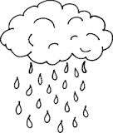 ____________________________________________

1. **Name these road signs.**

|  |  |
| --- | --- |
| D:\BECKY\images\DISAN PICS\pics\no parkng.jpg | D:\BECKY\images\DISAN PICS\pics PART 2\pics\danger ahead.png |
|  |  |

1. 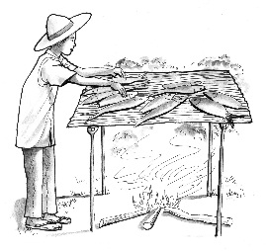What is the method of preserving food called?

_________________________________________

**LITERACY 1B**

1. __________________ animals are the animals we keep at home.

(Domestic, Wild)

1. **a) Write the animals for these homes.**
2. pigsty ___________________
3. basket ___________________
4. kraal ___________________

b) How many legs has a cow? ________________________________________________________

1. **Underline the means for road transport.**

boat lorry ship car bus train

1. 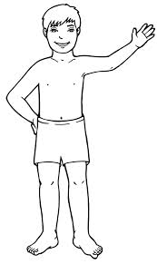**Name these gifts on your body.**

___________________________ ___________________

**\*\*\*END\*\*\***